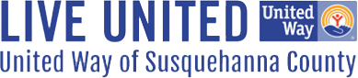

RAISE THE BAR - SPONSORSHIP PACKAGES

Reserve your sponsorship by emailing
tfollert@unitedwaysusqco.org by August 19, 2026.
Payment is due by August 19, 2026.
Pay online at www.unitedwayofsusquehannacounty.org

Choose the sponsorship level that best showcases your business:

$250 – Lager
- Logo displayed on event banner

$500 – Pilsner
- Logo displayed on the sponsor wall and event banner
- Logo featured in a group sponsor thank-you post on social media
- Business recognized in the event press release

$1,000 – IPA
- Logo displayed on the sponsor wall and event banner
- Logo featured in a group sponsor thank-you post on social media
- Business recognized in the event press release
- Business featured on rotating digital screen at the bar

$2,500 - Stout
- Logo displayed on the sponsor wall and event banner
- Logo featured in a group sponsor thank-you post on social media
- Business recognized in the event press release
- Business featured on rotating digital screen at the bar
- Presenting Sponsor of Live Music
- 3 Individual Thank You Posts on social media
- Logo featured on Celebrity Bartender T-shirts

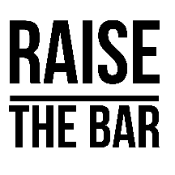
CAMPAIGN KICKOFF- RAISE THE BAR - SPONSORSHIP AGREEMENT

Thank you for sponsoring the 8th Annual Raise the Bar event on Thursday, September 3, 2026. This local celebrity bartending fundraiser and Campaign Kickoff will take place at Chet’s Place, 885 Tirzah Road, Union Dale, PA 18470, from 5:30 p.m. to 8:00 p.m.

To confirm your sponsorship, please email us by August 19, 2026 and return this completed agreement with payment by August 19, 2026. Mail checks payable to United Way of Susquehanna County to 67 Public Ave., Montrose, PA 18801, or pay online at www.UNITEDWAYOFSUSQUEHANNACOUNTY.org. If you would like your sponsorship credited to a specific bartender’s tip jar, please note that with your payment.

Please email your business logo to tfollert@unitedwaysusqco.org.

Sponsor / Business Name

Sponsorship Level Amount

Mailing Address

Contact Name

Phone Number

Email Address Website

Authorized Signature Date

Bartender you would like to support with your sponsorship:______________________________

www.UNITEDWAYOFSUSQUEHANNACOUNTY.org

67 Public Ave. Montrose, PA 18801 Phone: 570-432-0901; Fax: 570-432-0903

